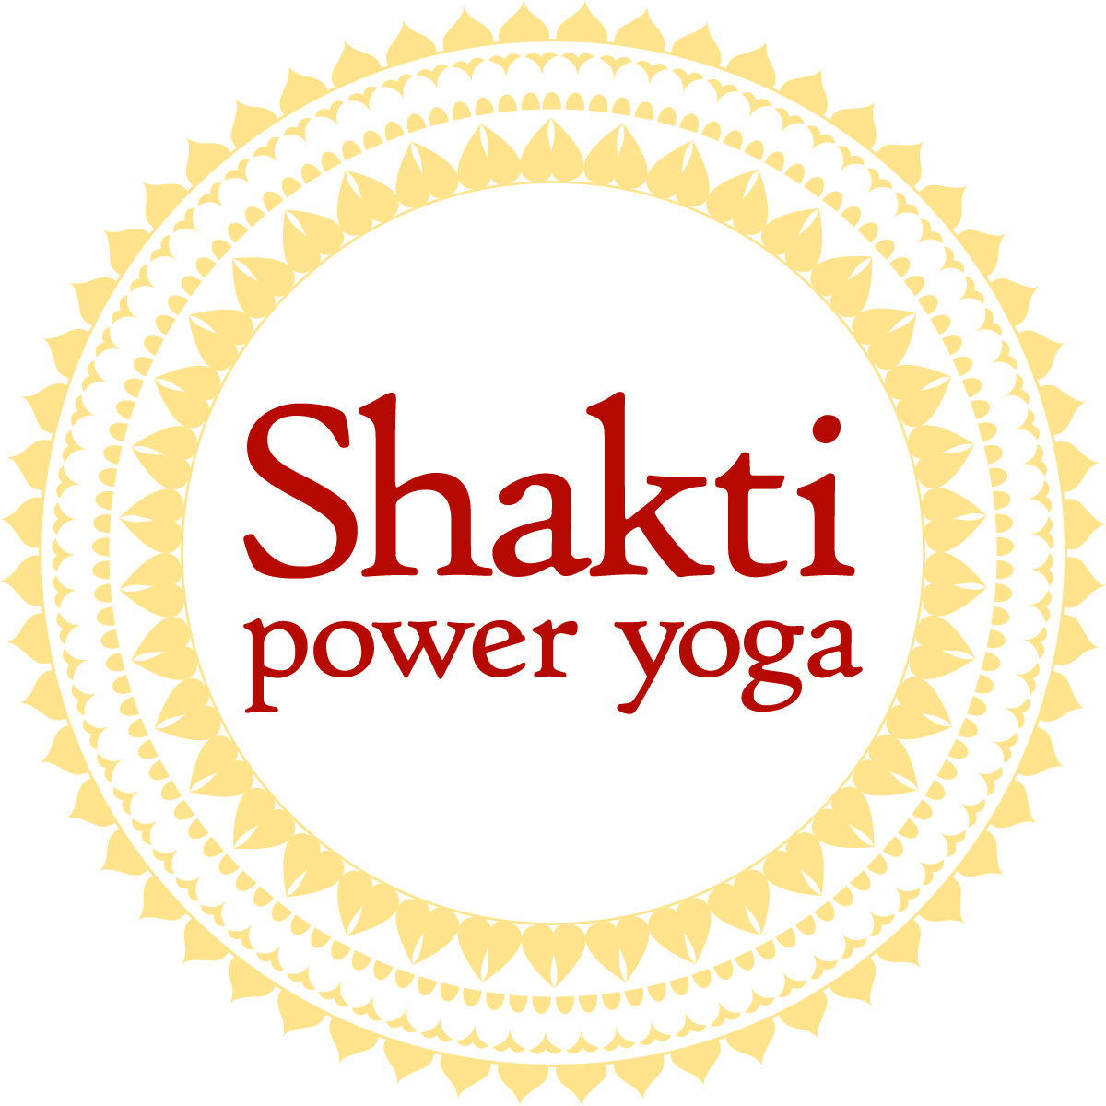

Contact: FOR IMMEDIATE RELEASE
Lauren Farina
615-942-8100/ lauren@shaktiyoganashville.com

Shakti Power Yoga Nashville to host PEACE TALK
with celebrated Yoga Instructor, Sid McNairy

NASHVILLE (For release January 24, 2013) Need a boost to your News Years Resolution? Shakti Power Yoga Nashville is standing for Peace! Join them this Saturday, January 26th at 6pm as they host Yoga Instructor, Sid McNairy for a PEACE TALK at their studio located at 65 Music Square East (Nashville, TN 37203). Sid, a celebrated Yoga Instructor who owns Sid Yoga in Towson, Maryland, will lead a discussion on peace to include: how to be at peace, how to live life in the challenges yet still remain in our center, how to decrease the hardships by living in a state of inner balance, and how to enhance your relationships: at work, with your partner, with your family, in everyday situations. The event is donation based with a $15 donation suggested. For more information contact the studio at 615-942-8100.
Along with the Peace Talk, Shakti Power Yoga is hosting a weekend of yoga workshops with Sid beginning on Friday, January 25th through Sunday, January 27th. The workshops are sold out for the weekend but anyone is invited to participate in the Peace Talk on Saturday night. “We all have an opportunity to grow spiritually from illness, injuries, and life setbacks. When we decide to go inside and find a way to go beyond we connect to a power that lies within each of us. My practice has allowed me to go in and empower myself in order to empower others! I am looking forward to leading and inspiring others at Shakti Yoga Nashville this weekend”, said Sid.
Sid McNairy is a celebrated yoga instructor who owns Sid Yoga in Towson, Maryland and who trained under teachers such as Baron Baptiste and Rodney Yee. A former football coach for Northern Illinois, Sid got into yoga to help his players heal their bodies. For more information on Sid McNairy, log on to www.sidyoga.com.
Shakti Power Yoga Nashville is an intimate yoga studio located in the heart of Nashville’s Music Row. Owners, Kelly Farina and Lauren Farina opened their doors in September, 2012 to empower students on and off the mat. Shakti Power Yoga offers several classes each day of the week and is more than just a place to take a class.. Their practice is rooted in gratitude, and focused on building strength, balance, and flexibility through a challenging and energizing Power Yoga practice. For more information on Shakti Power Yoga and for class schedule and pricing, log on to www.shaktiyoganashville.com.
-30-

